Type of the Paper (Article, Review, Communication, etc.)

Clustering and beamforming for efficient communication in Wireless Sensor Networks

Francisco Porcel1, J.F Valenzuela-Valdés1, P. Padilla1, F. Luna2, R. Luque-Baena3 and M.A. López-Gordo1

1 Department of Signal Theory, Telematics and Communications – CITIC, University of Granada. 18071 Granada, Spain.

2 Department of Computer Science and Programming Languages, University of Malaga. 29071 Malaga, Spain.

3 Department of Computer and Telematic Systems Engineering, University of Extremadura, 06800 Merida, Spain.Affiliation 1; e-mail@e-mail.com

**\*** Correspondence: juavalenzuela@ugr.es; Tel.: +34 958240849

Academic Editor:

Received: 31 May;

**Abstract:** Energy efficiency is a critical issue for Wireless Sensor Networks (WSNs) as sensor nodes have limited power availability. In order to address this issue, this paper tries to maximize the power efficiency in WSN by means of the evaluation of WSN node networks and their performance when both clustering and antenna beamforming techniques are applied. In this work, four different scenarios are defined by considering different numbers of sensors: 50, 20, 10, 5 and 2 nodes per scenario, and each scenario is randomly generated thirty times in order to statistically validate the results. For each experiment, two different target directions for transmission are taken into consideration in the optimization process (φ=0º and θ=45º; φ=45º and θ=45º). Each scenario is evaluated for two different types of antennas, an ideal isotropic antenna and a conventional dipole one. In this set of experiments two types of WSN are evaluated, in the first one all the sensors have the same amount of power for communications purposes, in the second one each sensor has different amount of power for its communications purposes. The analyzed cases in this document are focused on 2D surface and 3D space for the node location. Up to the authors’ knowledge, it is the first time that beamforming and clustering are simultaneously applied to increase the network lifetime in WSN.

**Keywords:** Wireless Sensors Networks; Energy efficiency; Beamforming, Optimization techniques.

PACS: J0101

1. Introduction

The next generation 5G wireless communications are currently being developed [1] [2]. Indeed, the first deployments of a 5G network are expected to be fully operating in 2020 [3]. The design goals of such systems are shown in Fig. 1. These systems are conceived to provide very high data rates (typically Gbps), extremely low latency, manifold increase in base station capacity and significant improvement in users’ perceived Quality of Service (QoS), compared to current 4G LTE networks [4]. There are many innovative technologies that will be used to satisfy the demands of massive volume of traffic and various devices: massive MIMO, orthogonal frequency-division multiple access (OFDMA), cloud radio access network (CRAN), software-defined networking (SDN), composite wireless infrastructures, flexible spectrum management, small cells, and heterogeneous network deployment, among others [5].

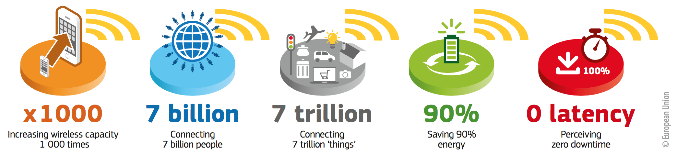

Fig. 1. Design goals and requirements for 5G networks. (from [3])

The research initiatives by industry and academia have identified eight major requirements [1] of the next generation 5G systems, being “the reduction in energy usage by almost 90%” one of them. Green technologies are thus being considered in the standard bodies. As a consequence, energy efficiency is therefore a key issue for the design of these networks [6]. Efficiency, in general, and energy consumption in particular, does clearly involve any sort of optimization. The required technologies for the developing of 5G systems as well as the application scenarios are quite numerous. One of the most potential cases of use of 5G [4] is in Wireless Sensor Networks. The expected number of connected “things” (IoT: Internet of Things) will be 7 trillion [3]. Therefore, it is clear that energy preservation for WSN is an issue of great concern in what related to network design and deployment, protocols and configurations, trying to maximize the performance of the nodes.

One option is to reduce the energy consumption by optimizing the way the wireless communications take place. The problem has to cope with the air interface (the radio signals) and how the radiation pattern (beam) is set up to reach the desired QoS with minimal energy consumption. The technique that enables this energy-efficient wireless communication is beamforming [7], which consists of several coordinated antennas radiating jointly to generate a directive beam for covering a given area with a very accurate precision. The goal is to reduce the energy consumption of the sensors by performing collaborative beamforming. This is a very important problem as the sensor nodes have limited power, and saving energy is critical. In this paper, the objective is to show that beamforming can be used in the context of WSNs to perform energy efficient communications, allowing the lifetime of this kind of distributed infrastructure to be steadily increased. To the best of our knowledge, this is the first approach in which the gain of the beamforming is accurately computed, in relation to the number of nodes, organized in different clusters in the WSN.

The paper is organized as follows. Section 2 describes the beamforming model used for WSN. Section 3 shows the optimization algorithm. Section 4 provides the results and an analysis and discussion of the results obtained. The conclusions are outlined in Section 5.

2. Collaborative Beamforming in WSN.

WSNs usually have the nodes arbitrarily located in a defined area. In many cases, this distribution is a random one. This has influence in the data transmission when considering collaborative nodes, not being easy to maximize the global transmission capacity of the network. In this context, beamforming has arisen as a good strategy in WSN for the complete system optimization in terms of energy efficiency and network capacity and reliability. The first approaches on this are dated only a few years ago. In [8], the authors prove the existence of an optimum feeding configuration for each individual element of the network when trying to maximize the transmission gain in a desired space direction. Moreover, in the results in [9] it is stated that 80% of the network energy is saved when applying beamforming. In [10], the authors provide a theoretical proof of the gain improvement if beamforming is applied. In this work, we compute iteratively the beamforming in an array of sensors to calculate the possible gain improvement based on this approach [11-12]

*2.1. Beamforming*

The beamforming techniques are based on the definition of a highly directive pattern in a desired direction, depending on the network operation conditions and the network transmitting necessities. Based on it, it is necessary to consider the field of each individual element contributing constructively in the desired pattern directions and destructively in rest of them, even provoking transmission nulls in some critical directions. The general pattern is made of the aggregation of the elementary ones, and five variables define the antenna array that the nodes form. These variables can be classified into two different categories, which are the radiating element nature and the spatial location:

1. Radiating element:The amplitude excitation of each unitary radiating element.
2. The phase excitation of each unitary radiating element.
3. The radiation pattern of each element, depending on the kind of antenna considered (dipole, slot, helix, patch array, bow tie, etc.).

Spatial location:

1. The separation among elements of the array, in terms of wavelength distance.
2. The antenna array geometry, which may be linear, circular, rectangular, or spherical, among other possibilities.

Considering classical array theory, the most convenient and affordable manner of placing the elements is a 1D line or 2D surface in which the elements are uniformly separated and with the same excitation in both amplitude and phase. This simple configuration let obtain a variation in the radiation direction when acting progressively over the phase of each element, preserving the Nyquist criterion which is related to the element separation (lower than half a wavelength). Unfortunately, this is not the case of WSN networks, whose nodes are distributed in space with distances that are much longer than a wavelength. However, there is still enough room to achieve benefits from applying beamforming, although it becomes a harder task to find the optimal configuration.

## *2.2 WSNs scenario model*

The experimental setup considered in this work implies a random node deployment in a squared area. The node location is based on a uniform distribution in both 2D coordinates, with no movement once the nodes are settled down. This approach is widely used in the definition of WSN experimental scenarios, as it can be found in [7] or [8]. In this scenario, each node has a limited power autonomy, which must fulfill the operation requirements for both data transmitting to the HECN and environment sensing.

The nodes are also equipped with different antenna types providing different antenna patterns, as depicted in the preceding section. Although it is typically assumed that the total available power is the same at each sensor, the distribution of power devoted to sensing or to data transmission can be modeled to be diverse. In this work, it is assumed that the node consumption for each task is commanded by random uniformly distributed variable of value [0,1]. Thus, the available Energy at sensor *x (x = 1, 2,…, max_sensors)*, Eax, is the following:

 (1)

where Et is the total available sensor energy and Fx is the uniformly distributed variable described above. Additionally, the energy consumed by each sensor (Ecx) is:

 (2)

where Ptx_x is the amount of power devoted to transmit the data in sensor *x* and tx is the transmission time. Notice that the node consumption can be also expressed in terms of power. Thus, the available power, Pax, is provided by:

 (3)

As it can be noticed, the maximum lifetime, tlife_x, for the sensors as a whole is obtained when the energy consumption is equal to the available energy:

 (4)

As a consequence, the lifetime of each sensor can be written as follow:

 (5)

At this point, it must be considered that Ptx_x is the power needed to transmit data without considering beamforming. However, when beamforming is applied, Ptx_x, which is related to the excitation in amplitude of each sensor is multiplied by a gain effect provided by the beamforming. This gain effect depends on the final radiation pattern and may induce gain in some directions and loss in others. Thus, the power to transmit data to the receptor is:

 (6)

where Ptx_x_B_A is the excitation in amplitude of each sensor and GB is the global gain value at the different directions of transmission/reception. Thus, Ptx_x considering beamforming is:

 (7)

Finally, the lifetime when adding beamforming, tlife_x_B, is:

 (8)

The main interest in this work is focused on the maximization of the lifetime of the WSN as a whole, applying beamforming for the data transmission among the sensors. This is translated into a search of phase and amplitude configurations, Ptx_x_B, at each sensor that maximize the final outcome:

max {} (9)

Notice that the sensor that first runs out of battery fixes the lifetime of the WSN.

*2.3. Optimization algorithm*

In order to address the problem defined above in Eq (9), a Genetic Algorithm (GA) has been adopted as the optimization algorithm because they have shown a quite good performance over a great variety of optimization problems [8]. GAs manage a pool of candidate solutions (the population), which represent tentative solutions of the target problem. In our case, these solutions are composed of the excitation (module and phase) of the sensors deployed in the WSN. The GA population is iteratively improved by using genetic operators (selection, recombination, and mutation) that follows the idea of “survival of the fittest”, i.e., new solutions are generated in each generation and replace worse solutions in the population. The process of iterating through successive generations is called evolution, and ends when a termination condition is fulfilled.

The GA included in the optimization toolbox of Matlab ® has been used. We want to note that we have not pay any attention to the parameterization of the GA, as it is not the goal of this paper to look for the best optimization algorithm for the problem addressed. Basically, the default configuration of this GA and standard settings are used: the population size has been set to 100; as genetic operators, Remainder selection, Heuristic crossover (with a probability of 0.8), and Uniform mutation (probability of 0.1); finally, the stopping condition is to perform 100 generations.

1. **Pattern Results**

The radiation patterns and their gains when applying beamforming are computed with [13], a Matlab toolbox ®. Beamforming requires all the nodes in the cluster to be synchronized, and this issue takes time: the higher the cluster size is, the longer the sync time needs to be. In this work we have fixed five different scenarios regarding the number of sensors implied: 50, 20, 10, 5 and 2 nodes per scenario. Additionally each scenario is randomly generated thirty times in order to statistically validate the results. For the scenarios of 50, 20, 10, 5 and 2 nodes, a transmission time of 40% 30%, 20%, 15% and 10% is used for synchronization, respectively. The time of transmission in beamforming technique is multiplied by the number of sensors because every sensor needs to transmit the data of all sensors. In each experiment, two different transmission directions are being considered for the optimization process (φ=0º and θ=45º; φ=45º and θ=45º). Then, the GA starts optimizing the antenna parameters installed in these sensors for performing the desired beamforming (a beam towards the HECN, which is located at the four different directions previously mentioned). Each scenario is evaluated for two different antennas, an ideal isotropic antenna and a conventional dipole one. In this set of experiments all the sensors are considered to be transmitting the same amount of power when acting in the network as a collaborative node.

*3.1. Pattern results*

Figs. 2 to 7 present the performance results. For all the figures, each row shows the results (normalized patterns) for five different randomly generated scenarios. At each subfigure, it should be noticed that, although the desired transmission direction implies a particular θ and φ value, the subfigures provide the radiation pattern results for the particular φ and the entire θ range (360º). In this θ range, the desired θ direction can be easily identified.

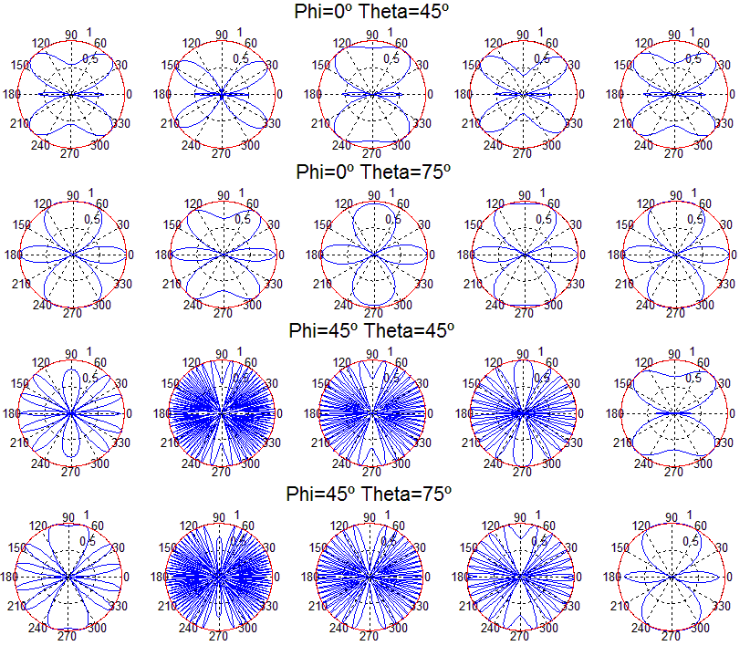

Fig.2. Radiation pattern for 2 sensors, different search angles: isotropic antenna.

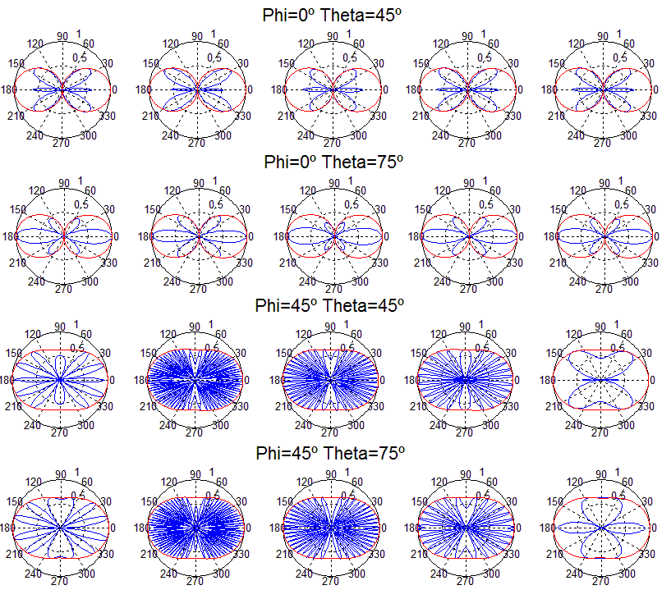

Fig.3. Radiation pattern for 2 sensors, different search angles: dipole antenna.

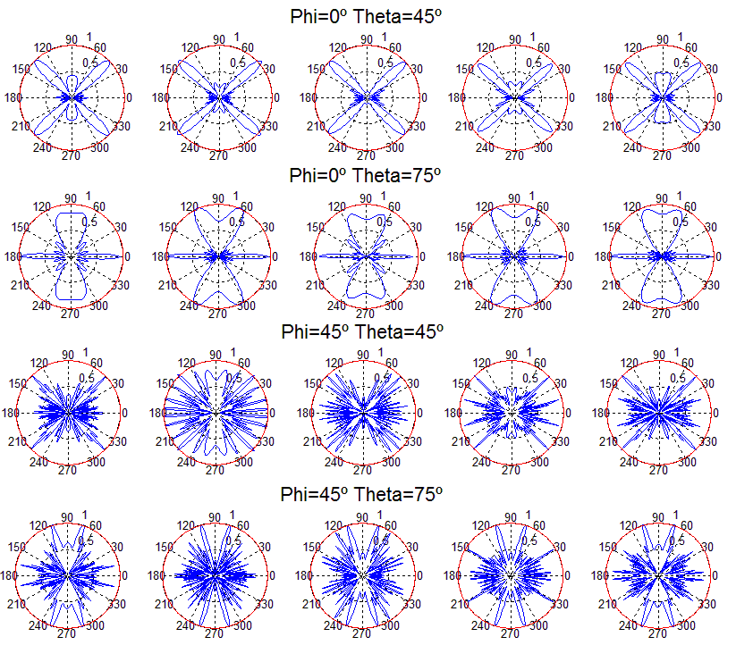

Fig.4. Radiation pattern for 5 sensors, different search angles: isotropic antenna.

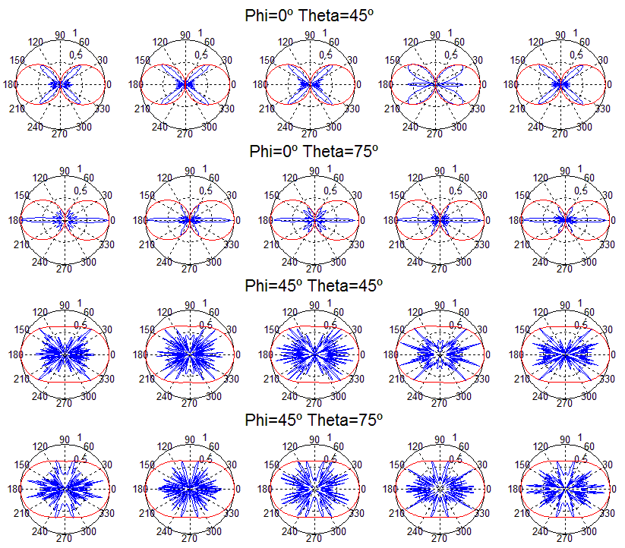

Fig.5. Radiation pattern for 5 sensors, different search angles: dipole antenna.

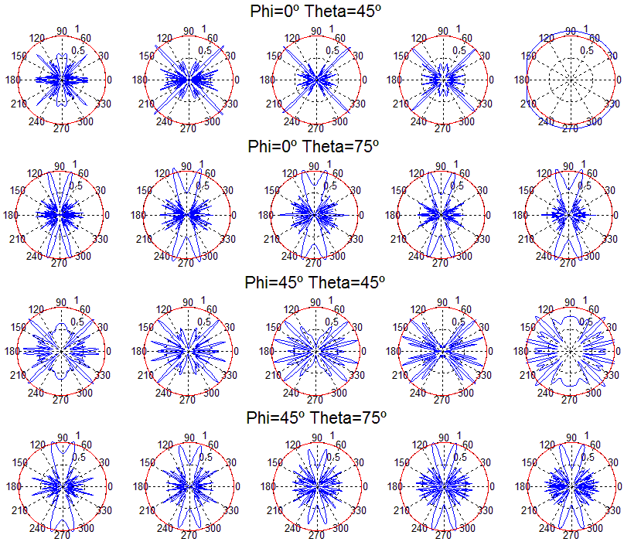

Fig.6. Radiation pattern for 20 sensors, different search angles: isotropic antenna.

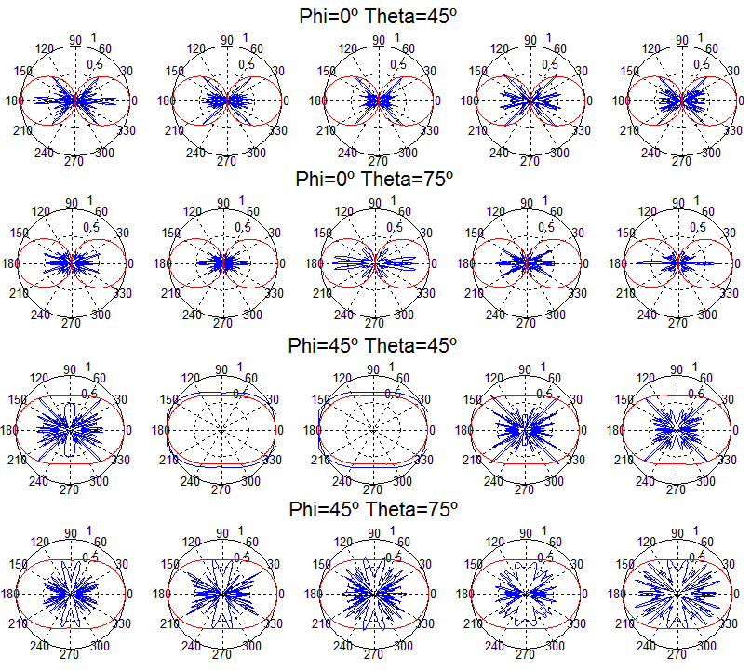

Fig.7. Radiation pattern for 20 sensors, different search angles: dipole antenna.

For all the figures, remember that the radiation patterns in each row are different because the inherent scenario has been randomly generated for each repetition of the five ones provided in a row. Figure 2 provides the beamforming results of two sensors with isotropic antennas for the two different angular configurations. It is observed that, although the desired direction is always obtained, there is still a high amount of radiated power towards other directions. This limitation is logical regarding the reduced number of sensors considered. As the number of nodes is increased, the radiated power towards directions different from the desired one is reduced, as it is clearly identified in Fig. 4. In the case of using a dipole (Fig. 3 and 5), the dipole radiation pattern adds a limitation in the beam that points towards the desired direction. The final beam is, thus, affected by the radiation pattern of the dipole, reducing the global gain achieved, as expected. When the number of nodes is high (20 nodes, Figs. 6 and 7), the desired beam becomes more directive, the number of the rest of beams is reduced and also their gain.

1. **Theoretical gain results**

In order to analyze the gain results, 4 different scenarios have been proposed. In the first one (A) all the sensors have the same power available for the communications (this is the case of a WSN composed with the same sensor type) and the sensors are placed only in two dimensions. In the second scenario (B) the sensors have random available power for communications (this is the case of a WSN composed with different sensor type) and the sensors are again placed only in two dimensions. In the third scenario (C) all sensors have the same available power for the communications but the sensors are placed in three dimensions. In the fourth scenario (D) the sensors have random available power for communications and again the sensors are placed in three dimensions.

*4.1 Theoretical Gain results*

In order to analyze the different gain factors implied in the energy efficiency in a WSN, in this subsection, it has not been taken into account the distance between the nodes and the HECN. That is, the gain factor obtained is only due to the beamforming technique. The gain results are analyzed: Figs. 8 to 10 provide the gain values for the two different desired search angles, all scenarios and both antennas, with 10 sensors, 20 sensors and 50 sensors respectively. The gain values are computed in terms of the increment factor regarding the gain in the case beamforming is not used, that is the gain obtained for a unitary node for the desired direction and provided by its antenna pattern.

In figure 8 it is shows the results for 10 nodes and 30 emulations for each scenario (4 scenarios for each subfigure). The subfigures have the following characteristics: isotropic ideal antenna (φ=0º and θ=45º) in subfigure a (up and left), dipole antenna (φ=0º and θ=45º) in subfigure b (up and right), isotropic ideal antenna (φ=45º and θ=45º) in subfigure c (down and left) and dipole antenna (φ=45º and θ=45º) in subfigure d (down and right). In all subfigures it is plotted with a red line the mean gain of each scenario. The aspect of all subfigures is very similar, that is, the influence of the directions and the antenna is very limited. For example the mean gain for the scenario A, for subfigure a is 6.50, for subfigure b is 6.60, for subfigure c is 6.51 and subfigure d is 6.61, which means that the maximum difference between subfigures is only the 0.11 (1,6%). However, the gain factor is different for the different scenarios, around 6.55 for scenario A, around 9.7 for scenario B, around 7 for scenario C and around 10 for scenario D. This means that the scenarios with fixed power have less gain than the scenarios with sensors with different power. This is because the genetic algorithm tries to assign to the node lower power to the communication. The lower the power to conform the beamforming is, the higher the lifetime of WSN is. For 10 nodes there exists little different between 2D and 3D scenarios.

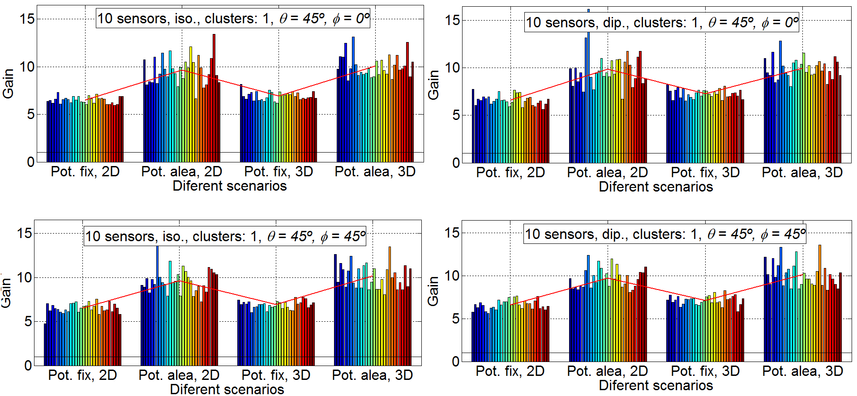

Fig.8. Gain results for 10 sensors. Isotropic ideal antenna, φ=0º and θ=45º in subfigure a (up and left), dipole antenna, φ=0º and θ=45º in subfigure b (up and right), isotropic ideal antenna, φ=45º and θ=45º in subfigure c (down and left) and dipole antenna, φ=45º and θ=45º in subfigure d (down and right).

In figure 9 it is shown the results for 20 nodes and 30 emulations for each scenario (4 scenarios for each subfigure). The subfigures have the following characteristics: isotropic ideal antenna, φ=0º and θ=45º in subfigure a (up and left), dipole antenna, φ=0º and θ=45º in subfigure b (up and right), isotropic ideal antenna, φ=45º and θ=45º in subfigure c (down and left) and dipole antenna, φ=45º and θ=45º; in subfigure d, (down and right). In all the subfigures, the mean gain of each scenario is plotted with a red line. Also for 20 nodes, the aspect of all the subfigures is very similar, that is, the influence of the directions and the antenna is very limited. For example the mean gain for the scenario B, for subfigure a is 16.03, for subfigure b is 15.91, for subfigure c is 16.41 and for subfigure d is 15.98, which means that the maximum difference between subfigures is only the 0.5 (3,0%). However, the gain factor is different for the different scenarios, around 8.4 for scenario A, around 16.2 for scenario B, around 10.7 for scenario C and around 18.8 for scenario D.Again, the scenarios with fixed power have less gain than the scenarios with sensors with different power for the same reasons that for 10 nodes. For 20 nodes there exists differences between the 2D and the 3D scenarios, the gain factors for 2D scenarios are around a 15% lower than the ones for 3D scenarios. This may be influenced by the major complexity of the calculations in the 3D case which may lead to non optimal solutions when the GAs algorithms are applied.

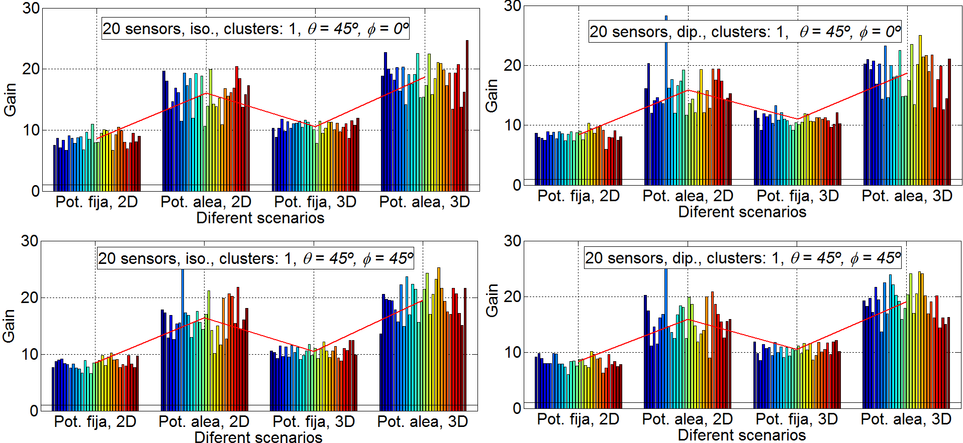

Fig .9. Gain results for 20 sensors. Isotropic ideal antenna, φ=0º and θ=45º in subfigure a (up and left), dipole antenna, φ=0º and θ=45º in subfigure b (up and right), isotropic ideal antenna, φ=45º and θ=45º in subfigure c (down and left) and dipole antenna, φ=45º and θ=45º in subfigure d (down and right). In figure 10, it is shown the results for 50 nodes and 30 emulations for each scenario (4 scenarios for each subfigure).. Again, in all subfigures the mean gain of each scenario is plotted with a red line. Also for 50 nodes, the aspect of all the subfigures is very similar, which means again that the influence of the directions and the antenna is very limited. For example the mean gain for the scenario D, for subfigure a is 22. 25, for subfigure b is 21.6, for subfigure c is 21.66 and subfigure d is 21.93, which implies that the maximum difference between subfigures is only the 0.65 (2,9%). As it is expected, the gain factor is again different for the different scenarios, around 7.75 for scenario A, around 15.8 for scenario B, around 10.3 for scenario C and around 21.6 for scenario D. This means, in similar way to the figures 8 and 9, that the scenarios with fixed power have less gain than the scenarios with sensors with different power. For 50 nodes exists more different between 2D and 3D scenarios, the gain factors for 2D scenarios are around a 30% less than for 3D scenarios for fix power and around 40% less for sensors with random power for communications. It is clear from figure 10 that the variability of scenarios with 50 sensors is high, for example, in the subfigure b in scenario D the emulation with more gain factor have 34 and the emulation with less gain have 13.4, that is the emulation with less gain is only the 39.4 % of the emulation with more gain. Explicar un poco más consultar con Pablo, debe ser debido a que le cuesta conformar más el haz y se acaban las genraciones…

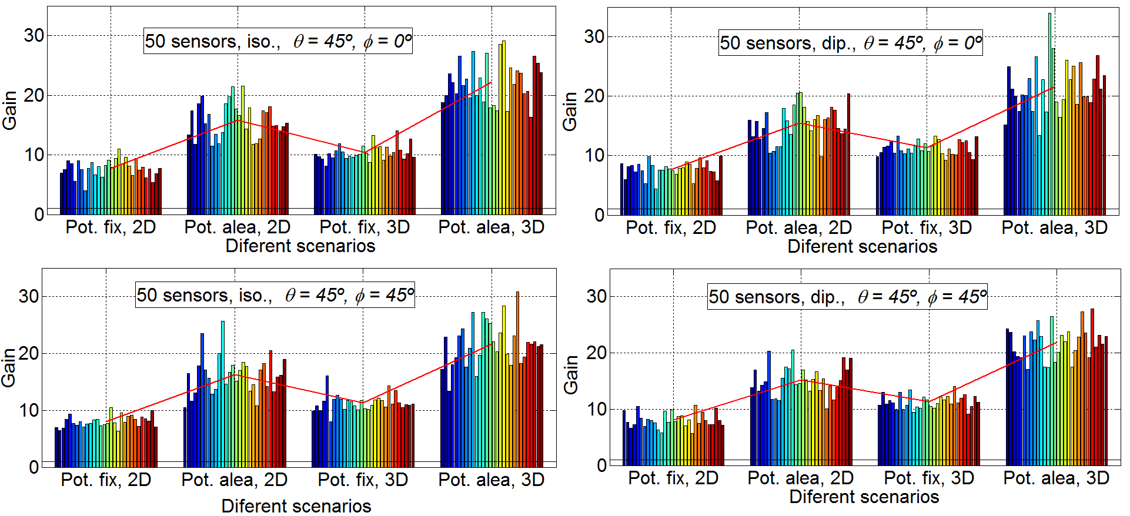

Fig.10. Gain results for50 sensors. Isotropic ideal antenna, φ=0º and θ=45º in subfigure a (up and left), dipole antenna, φ=0º and θ=45º in subfigure b (up and right), isotropic ideal antenna, φ=45º and θ=45º in subfigure c, (down and left) and dipole antenna, φ=45º and θ=45º in subfigure d (down and right).

In figure 11, it is shown that for the results considering 2, 5, 10, 20 and 50 nodes and 30 emulations for 4 scenarios (1 scenarios for each subfigure), the directions have a little influence. Consequently, it is shown only for φ=45º and θ=45º. The subfigures have the following characteristics: isotropic ideal antenna and scenario B in subfigure a (up and left), dipole antenna and scenario B in subfigure b (up and right) and isotropic ideal antenna, scenario D in subfigure c (down and left) and dipole antenna and scenario B in subfigure D (down and right). Again, in all the subfigures, the mean gain of each scenario is plotted with a red line. It is shown that the variability of the results increase with the number of sensors. With low number of sensors (2 and 5) the standard deviation of results is low and for high number of sensors (20 and 50) the variability is very high. Also, in this figure, it is shown that the gain increase with the number of elements except for 50 sensors. More details can be observed in table 1 and figure 12.

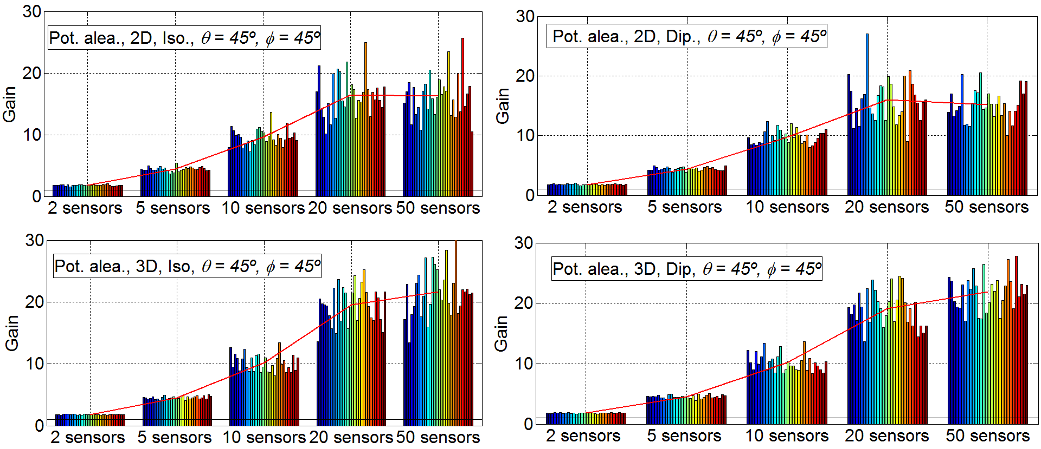

Fig.11. Gain results for 2, 5, 10, 20 and 50 sensors with φ=45º and θ=45º. Isotropic ideal antenna and scenario B in subfigure a (up and left), dipole antenna and scenario B in subfigure b (up and right) isotropic ideal antenna and scenario D in subfigure c (down and left) and dipole antenna and scenario B in subfigure d (down and right)..

Table 1 shows the Mean gain factor for all scenarios with two antenna and φ=45º θ=45º. In figure 12, it is show the same data that in Table 1 in graphical mode, moreover, it is added a lineal reference for visual performance. In this figure it is possible to observe that for low number of sensors (2 and 5) all scenarios works well, the main gain factor is approximately equal to the number of sensors. For an intermediate number of sensors (10), only the scenarios B and D obtain a mean gain factor near of the number of sensors, meanwhile the scenarios A and C loss more than 30% of the main gain factor respect to Scenarios B and D. No great difference between 2D and 3D is found. For 20 sensors the unique Scenario that has a mean gain factor similar to the number of sensors is the scenario D. With 20 sensors exists differences between all scenarios, 3D scenarios works better than 2D scenarios and scenarios with sensors with random power have more possibilities to conform beamforming than scenarios with sensors with fix power. Finally with 50 sensors, only 3D scenarios (C and D) increase the mean gain factor obtained with 20 sensors and the increase is little and very far from the number of sensors.

The main reason that explains this results of the GA has to do with the size of the instances and the stopping condition of the algorithm, which has been kept the same in all the scenarios. As the number of sensors increase, the search space to be explored by the GA becomes much larger, but the sampling size (i.e., the number of function evaluations) is constant: 100 individuals x 100 generations = 10000 evaluations. This clearly favors the small instances for which the GA is given more chance to find better quality solutions. Either increasing the population size of the GA, its number of generations to stop, or both would be required together with advanced diversity preservation mechanism that avoid the search to get stuck in local optima (premature convergence). In any case, there is room for improvement, especially when large instances are addressed.

|  |  |  |  |  |  |  |  |  |
| --- | --- | --- | --- | --- | --- | --- | --- | --- |
| (φ=45º θ=45º) | Scenario A | | Scenario B | | Scenario C | | Scenario D | |
| Nº Sensors | Iso | Dip | Iso | Dip | Iso | Dip | Iso | Dip |
| 2 | 1.83 | 1.86 | 1.80 | 1.81 | 1.79 | 1.81 | 1.80 | 1.80 |
| 5 | 4.18 | 4.19 | 4.43 | 4.42 | 4.20 | 4.28 | 4.50 | 4.52 |
| 10 | 6.51 | 6.62 | 9.63 | 9.75 | 6.91 | 7.14 | 10.16 | 10.18 |
| 20 | 8.42 | 8.36 | 16.41 | 15.95 | 10.52 | 10.57 | 19.54 | 19.1 |
| 50 | 8.02 | 8.06 | 16.26 | 15.16 | 11.34 | 11.33 | 21.66 | 21.93 |

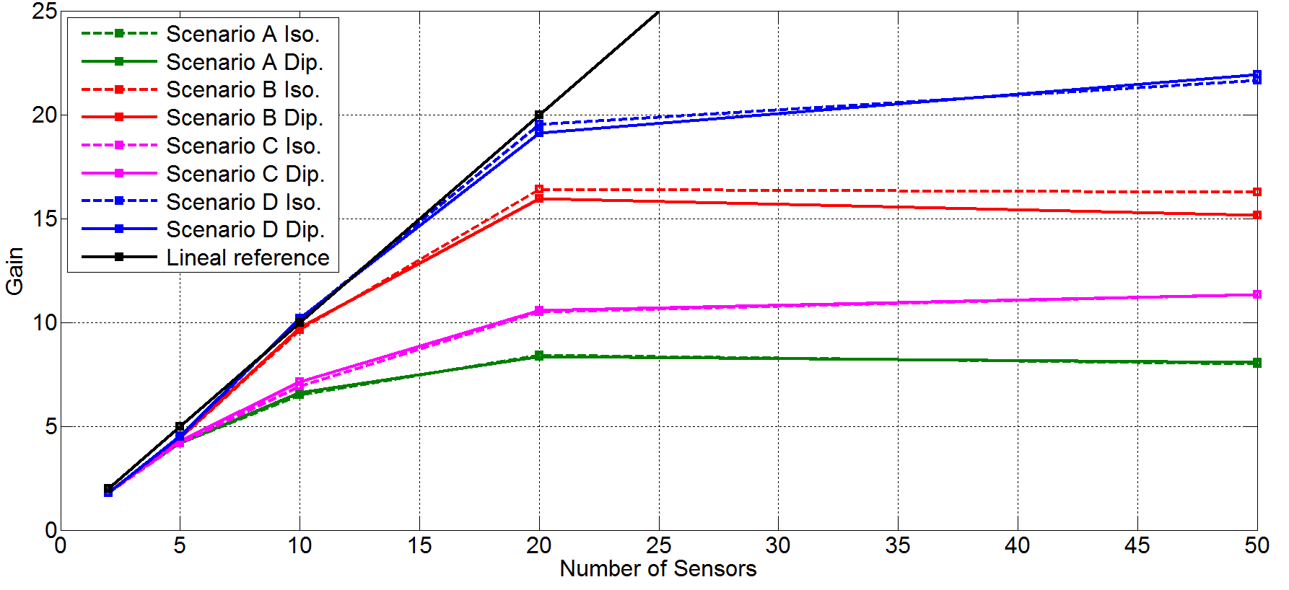

Fig.12. Results for search angle φ=0º, θ=45º, all scenarios and both antennas.

From the point of view of the node synchronization, the synchronization of 50 sensors can imply a significant problem because all the nodes must transmit at the same time. Also, the calculation of the amplitudes and phases is not a trivial aspect for a genetic algorithm because the number of variables to be optimized is equal to 100. Therefore, a good choice can be the clusterization of WSN, when the number of sensors is high. This is discussed in the next section.

*4.2 Cluster Gain results*

In this section, the sensor network has been divided into two clusters to study the behavior of the sensor network when the number of sensors is high. To split into two clusters sensors, we have used the method of k-means, which is one of the most simple and popular, as explained in [14]: “One of the most popular and simple clustering algorithms, K-means, was first published in 1955. In spite of the fact that K-means was proposed over 50 years ago and thousands of clustering algorithms have been published since then, K-means is still widely used”. The procedure is as follows:first the K-means algorithm is be applied to all sensors, obtaining two clusters, then, the beamforming technique is applied to the two clusters. To maintain the computational costs, it has been applied an unique genetic algorithm in order to optimize the two clusters simultaneously, so that only one genetic algorithm optimizes the phases and amplitudes of the two clusters. Obviously, it would be a better strategy to apply two different genetic algorithms, one to each of the clusters. Figure 13 shows the results of performing optimization with two clusters, where 10, 20 and 50 sensors are simulated. All the subfigures are for the Scenario D. The subfigures have the following characteristics: isotropic ideal antenna, φ=0º and θ=45º in subfigure a (up and left), dipole antenna, φ=0º and θ=45º in subfigure b (up and right), isotropic ideal antenna, φ=45º and θ=45º in subfigure c (down and left) and dipole antenna, φ=45º and θ=45º in subfigure D (down and right). In figure 13, it is shown that the gain factor is reduced (50%) when 10 and 20 sensors are simulated. This result is coherent since two clusters with half of elements are being combined. As is has been stated in previous sections, the gain for scenario D is approximately equal to the number of elements in the range of 0-20. It is observed that the variability of the results is much higher when considering two clusters than when considering just one. , esto es debido a… . However, with 50 sensors the gain achieved is about 12, not reaching the expected gain of 20. This gain value is expected because, with 2 cluster with more than 20 sensors, the gain at each cluster must be equal to the number of sensors in the cluster. The same explanation as in the previous section holds here. More sensors enlarge the search space to be explored by the GA, whilst is configuration remains the same concerning the number of function evaluations performed (sampling size).

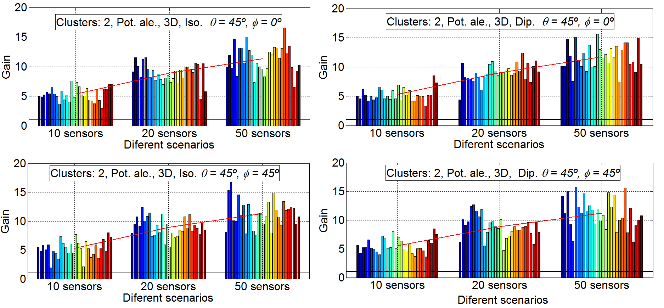Fig.13. Gain results with two clusters, 10, 20 and 50 sensors, Scenario D. Isotropic ideal antenna φ=0º and θ=45º in subfigure a (up and left), dipole antenna, φ=0º and θ=45º in subfigure b (up and right), isotropic ideal antenna, φ=45º and θ=45º in subfigure c (down and left) and dipole antenna, φ=45º and θ=45º in subfigure D (down and right).

1. **Gain results**

Up to now, we have taken into account the gain with beamforming in a certain pointing direction and compared with the directivity of the sensor in that particular direction. In this section, the received power calculation based on the distance to HENC applying the Friis formula is applied to calculate the propagation loss. The phase center of the array and the exact angle that is the HECN are available, was well as the distance to the central node and the angles of each of the nodes to transmit to the HECN. It has been performed simulations with 10 and 20 sensors and with one and two clusters. Simulations with 50 sensors have not been done because, as depicted in the previous sections, genetic algorithms with the standard parameters are not able to find a solution when the number of sensors increases. Figure 14 shows the results of performing optimization with one cluster, with 10 and 20 sensors.. This figure provides that the performance of the cases with perfect isotropic antenna is very similar to those obtained in the previous section. However, results with an antenna such as dipole are significantly better for 3D cases. This is because the radiation efficiency for some sensors is very low because at the exact angle at which the HECN station is, the dipole has a very low efficiency. This makes the lifetime of those sensors is very low. This problem does not occur when the beamforming technique is applied. Therefore the gain factor comes in some cases up to 45.

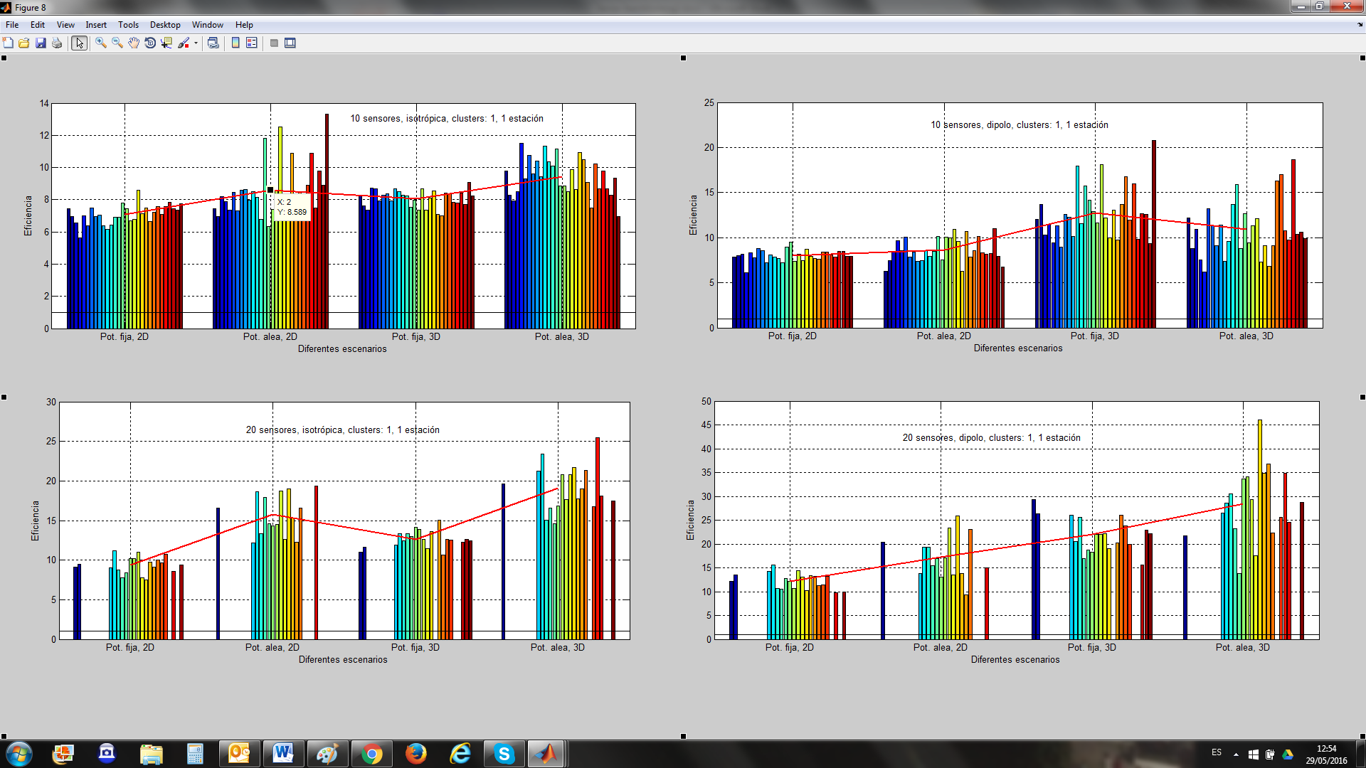Fig.14. Gain results with one cluster, 10 and 20 sensors, all scenarios. Isotropic ideal antenna and10 sensors in subfigure a (up and left), dipole antenna and 10 sensors in subfigure b (up and right), isotropic ideal antenna and 20 sensors in subfigure c (down and left) and dipole antenna and 20 sensors in subfigure D (down and right).

Figure 15 shows the results of performing optimization with two clusters, with 10 and 20 sensors. The results with two clusters for ideal isotropic antenna are very similar to those of the previous section. However, as it occurs in the case of one cluster, the case of two clusters, dipole antenna and 3D, the gain factor increases in the real case compared to the ideal case. As an example, the mean gain factor obtained in the Scenario D for two clusters is 12 for 20 nodes, while for the same case in Section 4.2 the mean gain factor is equal to 9.

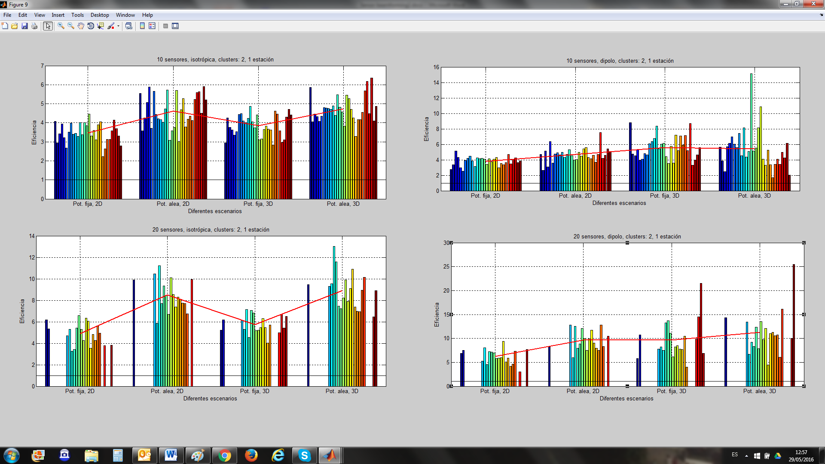Fig.15. Gain results with two clusters, 10 and 20 Sensors, all scenarios. Isotropic ideal antenna and 10 Sensors in subfigure a (up and left), dipole antenna and 10 Sensors in subfigure b (up and right), isotropic ideal antenna and 20 Sensors in subfigure c (down and left) and dipole antenna and 20 Sensors in subfigure D (down and right).

1. **Conclusions**

This work provides the evaluation of WSN node networks and their performance when both clustering and antenna beamforming are applied. In this work we have fixed four different scenarios and each scenario is simulated with different number of sensors implied: 50, 20, 10, 5 and 2 nodes per scenario, where each scenario is randomly generated thirty times in order to validate the results and their repeatability and reliability. For each experiment, two different transmission directions are considered (φ=0º and θ=45º; φ=45º and θ=45º) for the optimization process. Each scenario is evaluated for two different antennas, an ideal isotropic antenna and a conventional dipole one. In this set of experiments, two types of WSN are considered, in the first one all the sensors have the same amount of power for communication purposes, in the second one each sensor has different amount of available power. The analyzed cases in this document are focused on static nodes (no movement after the random scenario generation) and 2D surface and 3D for the node location.

In the results, when the desired direction is obtained with beamforming increasing the array directivity, the gain factor for a low number of nodes is equal to the number of sensors, which is an important conclusion of this paper. For a medium number of sensors, the gain factor is equal to the number of sensors only for Scenario D (sensors with different available power for communications and 3D distribution), that is, the scenario with the best performance is the scenario D, which is another important conclusion of this paper. Regarding the number of clusters, it is observed that the clusterization is a good strategy for a number of nodes higher than 20. The gain in the two cluster case is equal to the number of nodes of the cluster. Moreover, in real environment, with real antennas (dipole) the gain obtained with beamforming is higher for both cases (one and two clusters). Up to the authors’ knowledge, it is the first time that beamforming and clustering have been simultaneously applied to increase the network performance in WSN.

Future work is related to an improvement in the optimization algorithms in order to solve adequately scenarios with a high number of sensors. Also, the optimization of the number of clusters and the amplitude and phase of the sensors simultaneously may become another interesting work. Finally, it is possible to develop scenarios with multiple HECN (multiple directions) and multiple directions from which the WSN is being attacked (multiple directions towards which decrease the transmission power).

**Acknowledgments:** This work has been partially funded by the Government of Extremadura and the European Regional Development Fund (FEDER) under the IB13113 project.

**References**

1. M. Agiwal, A. Roym N. Saxena, “Next Generation 5G Wireless Networks: A Comprehensive Survey”, IEEE Communications Surveys & Tutorials, 2016 (Article in press) doi: 10.1109/COMST.2016.2532458
2. F. Boccardi, R. W. Heath, A. Lozano, T. L. Marzetta and P. Popovski, “Five disruptive technology directions for 5G”, IEEE Communications Magazine, vol. 52, no. 2, pp. 74-80, February 2014.
3. Community Research and Development Information Service (CORDIS), European Comission, “Research*eu, Focus Magazine 5G”, March 2015.
4. T. E. Bogale, L. B. Le, “Massive MIMO and mmWave for 5G Wireless HetNet: Potential Benefits and Challenges”, IEEE Vehicular Technology Magazine, vol. 11, no. 1, pp. 64-75, March 2016
5. C. W. Tsai, H. H. Cho, T. K. Shih, J. S. Pan, J. J. P. C. Rodrigues, “Metaheuristics for the deployment of 5G”, IEEE Wireless Communications, 22(6): 40-46, 2015.
6. S. Buzzi, C. L. I, T. E. Klein, V. Poor, C. Yang, A. Zappone, “A Survey of Energy-Efficient Techniques for 5G Networks and Challenges Ahead”, IEEE Journal on Selected Areas in Communications, 2016 (Article in press)
7. B. Bejar Haro, S. Zazo, D.P. Palomar, “Energy Efficient Collaborative Beamforming in Wireless Sensor Networks”, Signal Processing, IEEE Transactions on, vol.62, no.2, pp.496-510, 2014
8. J.L. Padilla, P. Padilla, J.F. Valenzuela-Valdés, José-Vicente Serrán-González, Miguel Angel López-Gordo “Performance Analysis of Different Link Layer Protocols in Wireless Sensor Networks (WSN)” Wireless Personal Communications, October 2015, Volume 84, Issue 4, pp 3075-3089
9. Jing Feng; Yung-Hsiang Lu; Byunghoo Jung; Peroulis, D., "Energy efficient collaborative beamforming in wireless sensor networks,". ISCAS 2009. IEEE International Symposium on Circuits and Systems, May 2009.
10. Ahmed, M.F.A.; Vorobyov, S.A., "Collaborative beamforming for wireless sensor networks with Gaussian distributed sensor nodes,", IEEE Transactions on Wireless Communications, vol.8, no.2, pp.638,643, Feb. 2009
11. J.F. Valenzuela-Valdés, F. Luna, R. M. Luque, P. Padilla, “Saving energy in WSNs with beamforming”, in Cloud Networking (CloudNet), 2014 IEEE 3rd International Conference on, pp. 255-260, 2014
12. J. E. Agudo, J. F. Valenzuela-Valdés, F. Luna , R. M. Luque-Baena, P. Padilla, Analysis of beamforming for improving the energy efficiency in wireless sensor networks with metaheuristics, Progress in Artificial Intelligence, 2016 (Article in press) doi: 10.1007/s13748-016-0087-z
13. Matlab toolbox <http://www.mathworks.es/es/help/phased/beamforming.html>
14. Anil K. Jain, “Data clustering: 50 years beyond K-means”, Pattern Recognition Letters, Volume 31, Issue 8, 1 June 2010, Pages 651-666,

H:\documents\layout\new template June 2014\figures\CC-BY logo original v1.wmf© 2016 by the authors. Submitted for possible open access publication under the   
terms and conditions of the Creative Commons Attribution (CC-BY) license (http://creativecommons.org/licenses/by/4.0/).